Olympia Unitarian Universalist Congregation
April 7, 2024
“The Interdependent Web” with Rev. Mary Gear

Reading I
Last Fall the Article II Commission of the Unitarian Universalist Association (UUA) released the final draft of its proposed revisions to Article II of the UUA bylaws that define the purpose and values of the UUA. Their work spanned almost 3 years including hundreds of meetings, receiving input and feedback from over 11,000 UUs’. The Commission’s work identified 7 core UU values, one of which is Interdependence. The Commission defines the core UU value of Interdependence this way:

Interdependence. We honor the interdependent web of all existence.
We covenant to cherish Earth and all beings by creating and nurturing relationships of care and respect. With humility and reverence, we acknowledge our place in the great web of life, and we work to repair harm and damaged relationships.

Part I: Theology
In 1985 by an almost unanimous vote at the annual gathering of Unitarian Universalists, called the General Assembly, the delegates gathered in Atlanta, Georgia adopted the 7 Principles and 6 Sources of Unitarian Universalism. While that simple statement makes this sound like adopting the 7 principles was a quick and easy process, it was anything but. In 1961, when the Unitarians and the Universalists consolidated their two religious organizations into one, it was a contentious process to hammer out the shared and guiding principles. So it was with some trepidation that UUs in the 1970’s sought to change the original principles, and it was UU women who led the movement for change.

The original 1961 principles were full of patriarchal and blatantly sexist language, like affirming the “the dignity of man.” In addition, there was consensus that Unitarian Universalism was more than its Judeo-Christian heritage and there was a growing concern about the relationship of humans to the environment.

In the mid-1970's, a workgroup was formed to draft new principles. The draft of 6 principles and 5 sources first came before the General Assembly in 1981 and immediately caused contention and conflict. Over the next few years, much discussion led to an inspired suggestion to separate the principles and the sources, and the addition of the 7th principle recognizing humanity’s part in the interconnected web of life. By 1985, the proposed changes were adopted.
You might think that the idea of interdependence was new to UU with the addition of the 7th principle affirming the interconnected web. But interconnection was part of Unitarian and Universalist theology from the beginning. Unitarians emphasized the inherent goodness and value of each person, rejecting the idea that humans are born in sin, depraved and drawn to evil. Early Unitarian minister William Ellery Channing preached about the human likeness to God, and that it was our connection and commitment to God that led us to improve ourselves and our society.
While Unitarians tended to place individuals at the center of their theology, Universalists centered God’s universal grace for all people. Universalist minister Hosea Ballou spoke of God’s desire for human joy and a society that reflected the qualities of love and care for all people.
Yet, there is a shadow side to our theological lineage, one that can be misconstrued as interconnection. Both traditions believed in the perfectibility of individual character and of society, and it is through our charitable works that we would perfect ourselves and our society. This perspective tends to center on the individual, asserting that we would become righteous through our actions. This contributes to a sense of paternalism, hierarchy and superiority. It leaves no room for struggle, failure, or reality of how we hurt each other, of how we are truly interdependent.
This perspective of perfection and paternalism led some prominent Unitarians to delay or withhold their support for emancipation of slaves in the 19th Century and led some prominent Universalists to support the theory of eugenics in the early 20th Century. The perspectives of paternalism, hierarchy, and superiority show up in our modern UU Association and UU congregations; we call it white supremacy culture, patriarchy, classism, and other oppressions.
And so, we are coming around full circle as we prepare to once again vote to modify our UU principles and sources. This June at the annual gathering of UUs, still called the General Assembly, we will vote on whether to adopt values gleaned from our lineage and informed by our current context. OUUC will be able to send 7 delegates to this GA. If you are interested in being part of this historic vote as an OUUC delegate, please reach out to me or Rev. Sara.
With this complicated lineage and history, and despite our living tradition that adapts to current times, we are still faced with a fundamental tension in our theology: the push and pull between individualism and interdependence.

Reading II Anne
Our second reading is from “Finding Hope in Uncomfortable Truth” by Alice Kurima Newberry, in the 2022 Fall/Winter issue of The UU World.

When we’re living with these existentially foreboding times, our first response to the harm and violence around us must be to build kinship with one another. Community building offers radical hope. It reminds us that despite a world filled with trauma, violence, greed, and badness of many kinds, we’re able to claim immense power by knowing that there is life worth fighting for. When we build resilient relationships with each other, we build networks that the system cannot destroy. When we actively choose to fight for life, we’re claiming what cannot be taken from us: hope.

Part II: Relationships
One way to consider the current 7 principles is they are bookended by the 1st and 7th principles, which are theological statements. The 1st principle asserts that we affirm the inherent worth and dignity of every person; the 7th principle asserts that we affirm respect for the interdependent web of all existence of which we are a part. The 1st and 7th principles address the individual and interdependence.
The 2nd through 6th principles have more to do with process and behavior; they speak of things like justice, equity, acceptance, freedom, responsibility, democracy.
The proposed update to the UU principles that we will vote on in June is in the form of core values represented by this flower graphic.
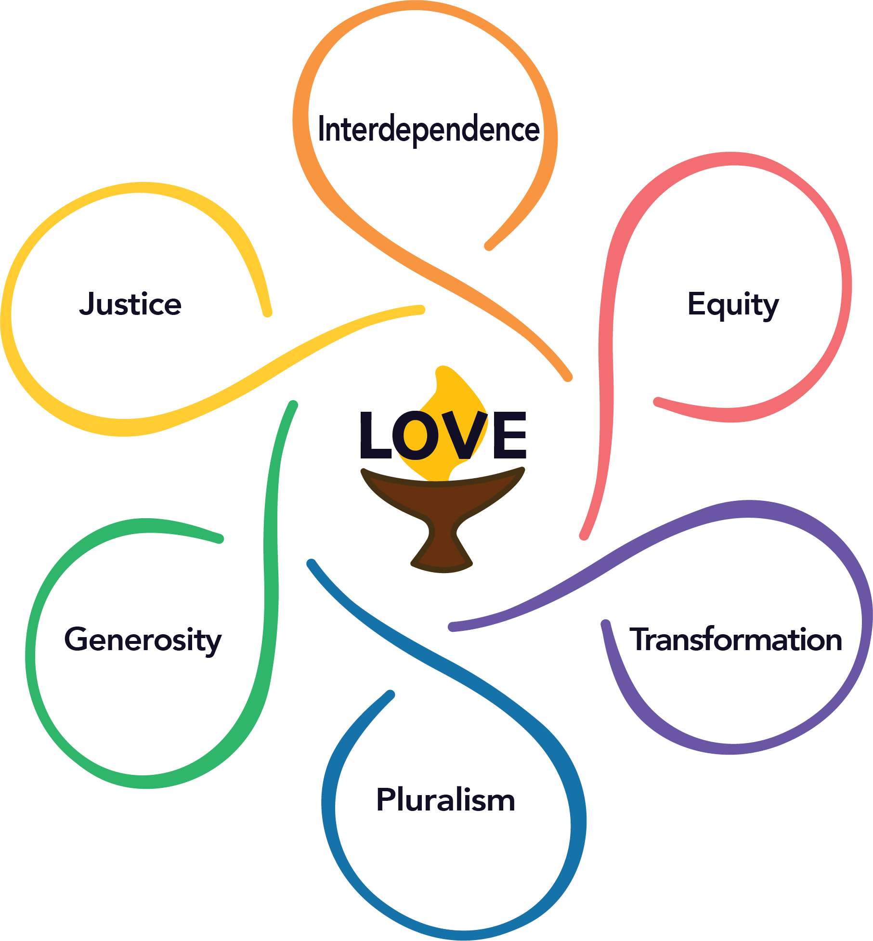

The current 7 principles are in there, they are just expressed differently and more in line with the cultural and theological context of these times. Our lineage and history are there, and the statement of who UUs are, is adapted to current sensibilities. We do this as a liberal religious tradition that is always growing and changing.
What I find interesting is that the tension of individualism and interdependence is still present in the core values, and I see an effort to address this tension.
Interdependence is expressed as a core value on its own and is our spiritual theme for this month. The affirmation of the individual is expressed in two different core values-Equity, our spiritual theme for last month, and Pluralism, our spiritual theme for next month.
The core value of Equity declares that every person has the right to flourish with inherent dignity and worthiness and goes on to covenant that we use our resources to build and sustain inclusive and sustainable communities.
The core value of Pluralism celebrates that we are all diverse, sacred beings, and that we embrace commonalities and differences with Love (capital L, Love), curiosity, and respect.
What I see in each of these core values is an effort to place the individual squarely in the context of community. Yes, we affirm the inherent worth and dignity of every person regardless of our differences, and we covenant to build communities that are inclusive, treating differences with respect, curiosity, and Love. Rather than demanding that we center either the individual or the collective, the proposed core values offer both, and. To me, this shows a maturity in our evolution as a faith tradition away from binary thinking toward inclusivity.
Just like the current Article II statement of principles and purposes, the proposed Article II update also clearly states our covenant. Our religious tradition is non-credal, so what binds us together is not beliefs but the promises that we make to each other about how we will be together; we make covenants. Each core value comes with a statement of covenant about how we will be together. Covenants are one way that we address the reality that we struggle, we make mistakes, and we hurt each other. It is a way that we approach each other with humanity and humility, recognizing that we are not here to be perfect, but to notice the grace and connection that is already here.
One of the ways I find it helpful to frame this tension with individualism, interdependence and covenants is the idea of “Me space, You space, and We space.” “Me space” and “You space” recognizes that we are individuals, and there are rights and responsibilities that come with being an individual. “We space” is where we intersect, it’s the space between us, the strands in the interdependent web. “We space” is what covenants address—how we will be together in the space that we share.
Just like the UUA and most other UU congregations, this congregation has a covenant. We have been in the process of revisiting that covenant for the past 18 months, with a proposal to modify the current covenant to remove ableist language, and to add a behavioral covenant to the current covenant. You can find printed information about this project in the Commons after the service and on the website at the link in the chat.
[ https://www.ouuc.org/ouucs-congregational-covenant-project/ ]
The workshop after the service today offered by the Dispute Resolution Center is intended to help us build the skills needed to live our core values of interdependence, equity and pluralism, and to live into our covenant. The workshop is about how to communicate across differences, finding commonalities where possible and building bridges where needed. The workshop is onsite and online from 12-2 with a light lunch provided for participants onsite. We hope you’ll join us.
I say often that what we learn and practice in here is what we take out there. Learning how to be together in ways that embrace commonalities and differences with respect, curiosity and love is so needed in our divided and divisive culture. We are still emerging from the pandemic, figuring out how to be in a very different world than 4 years ago. We are experiencing a climate crisis as the natural world, which our speaker Peter Jabin spoke so eloquently about a few weeks ago. We are experiencing unprecedented challenges to our democracy. And we know that many of the practices and systems we have in place are not just for black, indigenous and people of color; we’re calling for racial justice. The times, they need changin’.

Reading III
Our final reading is “The Task of the Religious Community” Rev. Dr. Mark Morrison Reed

The central task of the religious community is to unveil the bonds that bind each to all. There is a connectedness, a relationship discovered amid the particulars of our own lives and the lives of others. Once felt, it inspires us to act for Justice.
It is the church that assures us that we are not struggling for justice on our own, but as members of a larger community. The religious community is essential, for alone our vision is too narrow to see all that must be seen, and our strength too limited to do all that must be done. Together, our vision widens and our strength is renewed.

Part III: Justice

Like many others, I believe that the Earth will survive this phase in its long history, she has survived many crises. Whether humanity survives is an open question. The best chance we have of survival is if we recognize our interdependence and figure out how we will live in relationship with each other, with the beings we share this earth with, and with Gia herself. This is counter cultural in a society that reveres rugged individualism. This is sacred work requiring a spiritual foundation that recognizes the dignity and worth of individuals and our dependence on each other. This work is absolutely counter-cultural to American hyper-individualism, and that is why we need each other in a faith community.
UUs are not the only tradition to emphasize interconnection and interdependence. Modern day Buddhist theologians and social reformers like the Dhali Lama and Thich Nhat Hanh preached interconnection as the foundation for justice. Modern day Christians like the Rev. Dr. Martin Luther King, Jr. and Archbishop Desmond Tutu spoke of interdependence as the foundation for justice. Young activists like adrienne marie brown, Tema Okun, Alicia Garza, Patrisse Cullors, and Opal Tometi, are all teaching and modeling what it means to use interdependence as a foundation for justice. Muslims and Jews around the world are preaching interconnection as the foundation for justice as we call for a cease fire and release of hostages in Jerusalem and Gaza. The theology of interdependence connects UUs to other traditions, too.
I believe that acting as if we are interdependent is the only way we humans will survive what is ahead. We know now that “survival of the fittest” means that those who can be in community with kindness and cooperation will survive. We see this in nature and in human behavior, even Darwin commented on it. The time we see altruism is in a crisis. And we are in a crisis, several of them. The way through the crises before us is the same way it has always been—people coming together to name what is happening and do what is needed. We must not only recognize our interdependence but act as if we believe it. That is the work of justice in a culture that prioritizes the rights of the individual and minimizes or erases the responsibilities to others.
The pandemic taught us that we are connected; what we did regarding Covid-19 affected the health, wellbeing and even life of others, and what others did affected us. When the world shut down to help stop the spread of the virus, the world quieted, the smog cleared, wildlife came out again, birds, wolves, wild cats. The natural world took a breath. Now we’ve roared back with human impacts on the environment even more than pre-pandemic times, and we just completed the hottest 10 months in history. While I know that we can't be in crisis mode and shut down all the time, I wonder if we learned the lessons of the pandemic at all. And how quickly we forget.
I’ve told the story before of the inspiration I got from a friend when I was feeling despair about the state of the world. She reminded me that everything is connected, so just pick an issue and work on it in whatever way you can. If you work on poverty, you will address climate justice. If you work on racial justice, you will affect economic justice. If you work on democracy, you will have an impact on reproductive rights. Maybe what you can do is vote and encourage your like-minded friends and family to do the same. Maybe what you can do is support your trans child and their friends. Maybe what you can do is send money to groups helping women access reproductive health care across state lines. Maybe you can help repair damaged relationships among your neighbors. Maybe you can help address racism in Olympia. Just find something and do it.
Underneath all of this is the theology of interdependence—we are connected, everything is connected. Let’s live as if this were true, because deep down, we know it is.
I am going to ask you to do one thing this week, and it is the spiritual practice of Namaste. Namaste is a Sanskrit word that translates as “I bow to the divine in you.” If you are not comfortable with the language of the Divine, you might think “The light in me sees the light in you” or simply “I see you.”
This simple spiritual practice is to place your hands at your heart center and bow as you say “Namaste.” Easy and profound. In that one word, we are honoring “We space,” and we are acknowledging that we are all connected. It will take much more than this practice to heal the world, and it is a practice to remind us that we are connected as we begin again and again.
Let’s try it together. I invite you to turn to someone near you or on your screen if you are online and offer this sacred blessing.
Namaste.
In the sacredness of this “We space,” let’s be in silence together.
~~~~~
Prayer: “Breath With Me” by Rev. Matt Alspaugh
Breathe with me
Breathe with me—the breath of life
Inhale, Inspire, Inspiration,
Ruacḥ, Pneuma, Spiritus, the Holy Spirit
the many names for breath.
Breathe with me.
Know that with each breath we take in molecules of air
that were breathed by every person that ever lived.
Breathe with me,
and breathe the breath of Jesus, of Moses,
of Mohammed, of the Buddha.
Breathe with me,
and know that we are all interdependent,
that the spirit of life
flows through us all.
Breathe with me,
as we come together to do the holy work
of interconnection and relationship,
that our work here may be blessed.
Amen

